Day 21
24 July 2025
Mohammed Arsalain
mobarsal@amazon.com
SOLID
Liskov Substitution Principle 👍

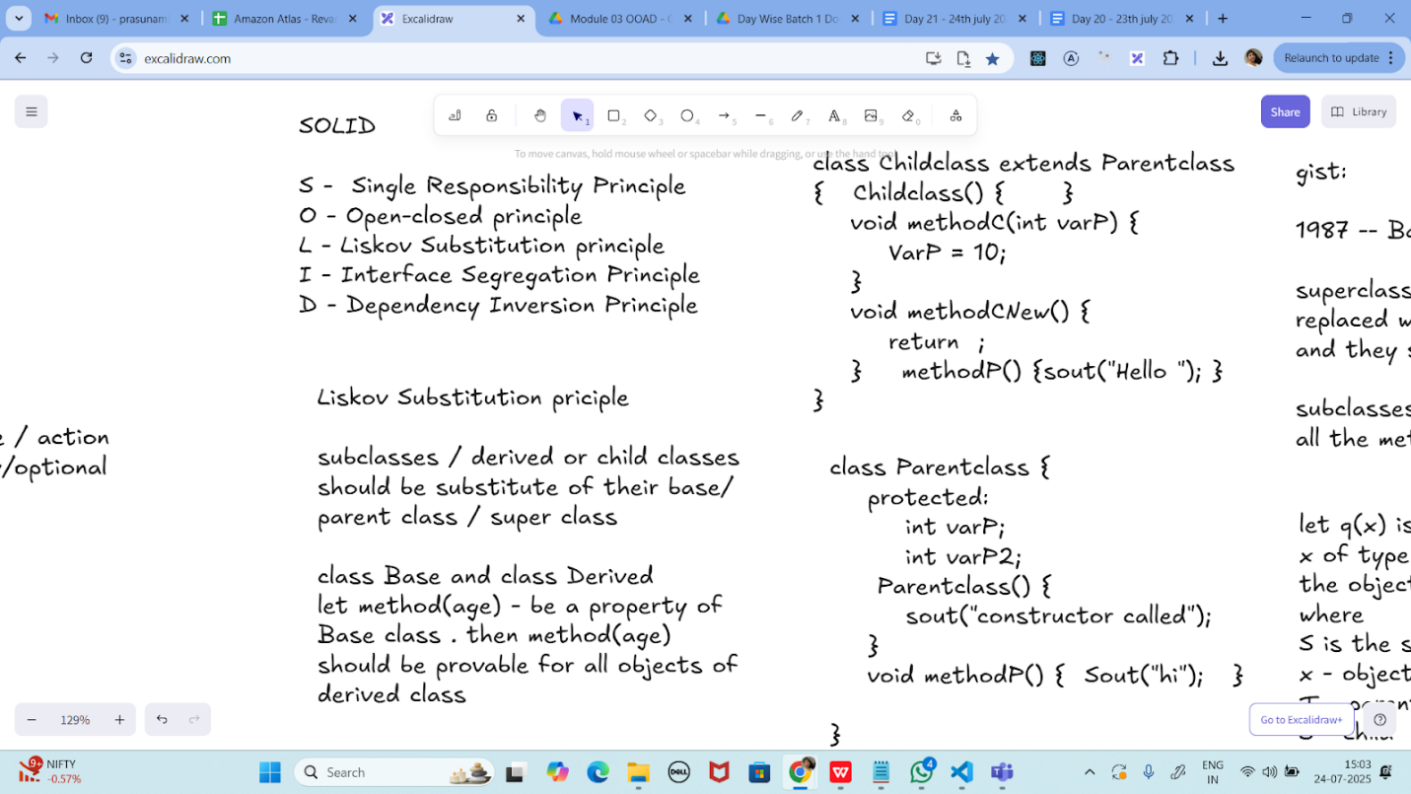

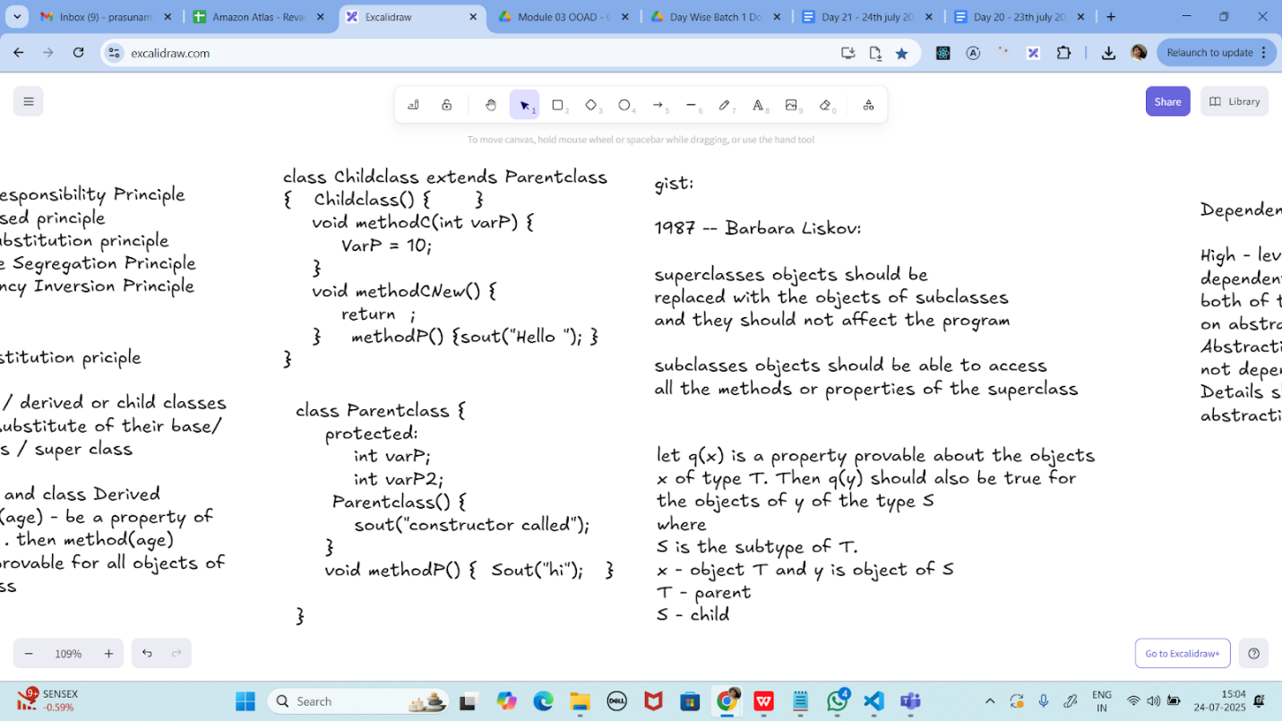

Task 01:
class Animal {
void sound() {
sout(" sounds of different animals");
}
}
class Cat extends Animal{
@Override
void sound() {
sout(" Meow is the sound of cat");
}
}
class Main{
psvm(String[] args) {
Animal obj = new Cat();
obj.sound(); //Meow is the sound of cat
}
}
issue with Substitution and Generics

Java Generics -- it has introduced a challenge - substitution principle...

is cat a subtype of Animal, List<cat> is not a subtype of List<Animal>

List<Cat> Cobj = new ArrayList<>();
List<Animal> Aobj = Cobj; ===// this will give you a wildcard ,

wildcards:

1. unbounded Wildcard
? ===> any data type if you want to use you can use ?

2. Bounded Wildcards with an upper bound (? extends Type)

===> yopu will use it when you need to accept a type and its own subtypes

3. Bounded Wildcards with an lower bound (? super Type)
===> you will use when ypou need accept a type and its super types

Unbounded wildcards:
Task 02:
they are useful when the code does not depends on the actual type parmeter

void printList(List<?> list) {
for(Object element: list) {
sout (element);
}
}

List<Cat> clist = new ArrayList<>();
clist.add(new Cat());
printList(clist); //

---------------------------
Task 03:

Upper Bounded Wildcards

void animalSound(List<? extends Animal> animalList) {
for(Animal elements : animalList
elements.sound();
}
}
List<Cat> cats = new ArrayList<>();
cats.add(new Cat());
animalSound(cats); //meow

----------------------------
Task 04:

lower Bounded Wildcards

void addAcat(List<? super Cat> cats) {
cats.add(new Cat());
}
List<Animal> animals = new ArrayList<>();
addAcat(animals); //

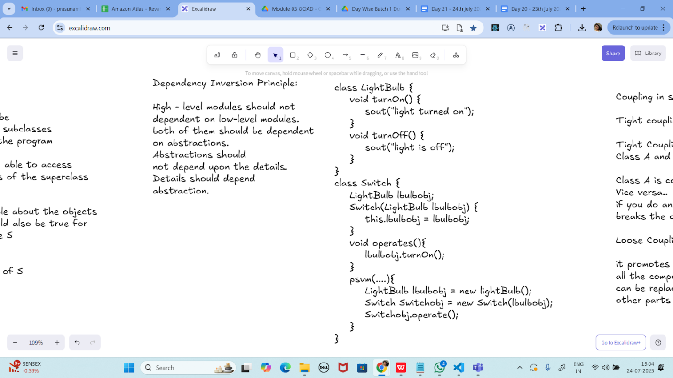

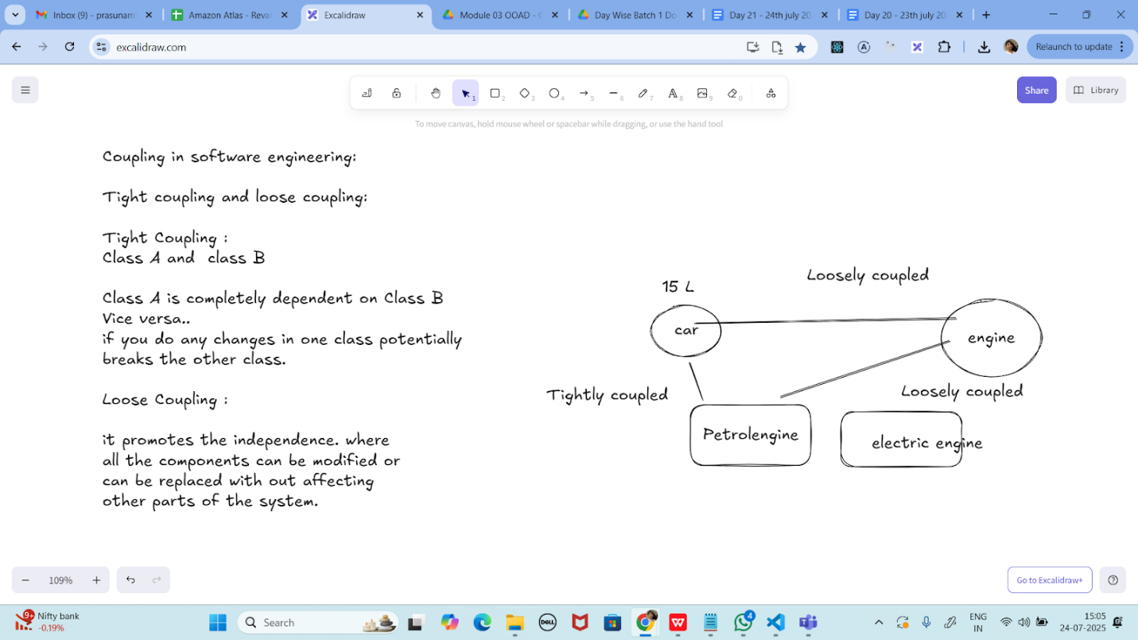

Task 01:

class Animal {
void sound() {
sout(" sounds of different animals");
}
}
class Cat extends Animal{
@Override
void sound() {
sout(" Meow is the sound of cat");
}
}
class Main{
psvm(String[] args) {
Animal obj = new Cat();
obj.sound(); //Meow is the sound of cat
}
}

10.33 to 10.38

issue with Substitution and Generics

Java Generics -- it has introduced a challenge - substitution principle...

is cat a subtype of Animal, List<cat> is not a subtype of List<Animal>

List<Cat> Cobj = new ArrayList<>();
List<Animal> Aobj = Cobj; ===// this will give you a wildcard ,

wildcards:

1. unbounded Wildcard
? ===> any data type if you want to use you can use ?

2. Bounded Wildcards with an upper bound (? extends Type)

===> yopu will use it when you need to accept a type and its own subtypes

3. Bounded Wildcards with an lower bound (? super Type)
===> you will use when ypou need accept a type and its super types

Unbounded wildcards:

they are useful whern the code does not depends on the actual type parmeter

void printList(List<?> list) {
for(Object element: list) {
sout (element);
}
}

List<Cat> clist = new ArrayList<>();
clist.add(new Cat());
printList(clist); //

class Student {
public int roll_no = 10;
//private int roll_no = 10;
public int getRoll() {
System.out.println("getRoll method");
return roll_no;
}
public void setRoll(int roll) {
if(!(roll > 100))
roll_no = roll;
}
}
class Tight_Coupling01 {
public static void main(String[] args) {
Student sobj = new Student();
sobj.roll_no = 10;
//sobj.roll_no = 110;
System.out.println("the roll no of student is "+ sobj.roll_no); // 110
}
}

Task 05:

// tight coupling

class Student {
public int roll_no = 10;
//private int roll_no = 10; // this code breaks...
public int getRoll() {
sout("getRoll method");
return roll_no;
}
public void setRoll(int roll) {
if(!(roll > 100)
roll_no = roll;
}
}
class Tight_coupling {
psvm(String....) {
Student sobj = new Student();
sobj.roll_no = 10; // we are not following the rule of Student class roll no > 100..
//sobj.roll_no = 110;
sout("the roll no of student is "+ sobj.roll_no); // 110 // private - error //10
}
}

Task 06:

// loose coupling

class Student {
private int roll_no = 0;
public int getRoll() {
sout("getRoll method");
return roll_no;
}
public void setRoll(int roll) {
if(!(roll > 100)
roll_no = roll;
}
}
class Loose_coupling {
psvm(String....) {
Student sobj = new Student();// Person pobj = new Student(); // person got a bonus
sobj.setRoll(10);
sout("the roll no of student is "+ sobj.getroll();
}
}

/*

Module 1 Module 2 Module 3
independent .. they do communicate

// we should do coupling -- importance

good maintainability
testability
Error propagation
high coupling - errors and it will propagate throught the project.. not at all recommandable..
reusability:

No coupling :

the modules wont interact with eachother.. -- completely independent..

*/

Task 07:

//DIP violating

class LightBulb {
void turnOn() {
sout("light turned on");
}
void turnOff() {
sout("light is off");
}
}
class Switch { // switch class directly depends on the lightbulb class ---- DIP violating
LightBulb lbulbobj;
Switch(LightBulb lbulbobj) {
this.lbulbobj = lbulbobj;
}
void operates(){
lbulbobj.turnOn();
}
psvm(....){
LightBulb lbulbobj = new lightBulb();
Switch Switchobj = new Switch(lbulbobj);
Switchobj.operate();
}
}

Task 08:

DIP implementation:

interface SwitchOnOff {
void turnOn();
void turnOff(); // void remoteControl();// void alexaVoiceControl();
}
class LightBulb {
void turnOn() {
sout("light turned on");
}
void turnOff() {
sout("light is off");
}
} // or class fan, class inverter, class washing machine...(in future remote for washing machine
// i can extend without modification..
class Switch { // switch is depending on switchonoff class not on light bulb..
SwitchOnOff device;
void Switch(SwitchOnOff device) {
this.device = device;
}
void operates() {
device.turnOn();
}
}
class DIP {
psvm(....){
SwitchOnOff lbulbobj = new LightBulb();
Switch lightswitch = new Switch(lbulbobj);
lightswitch.operate();
}
}

Association, Composition, Aggregation, Inheritance
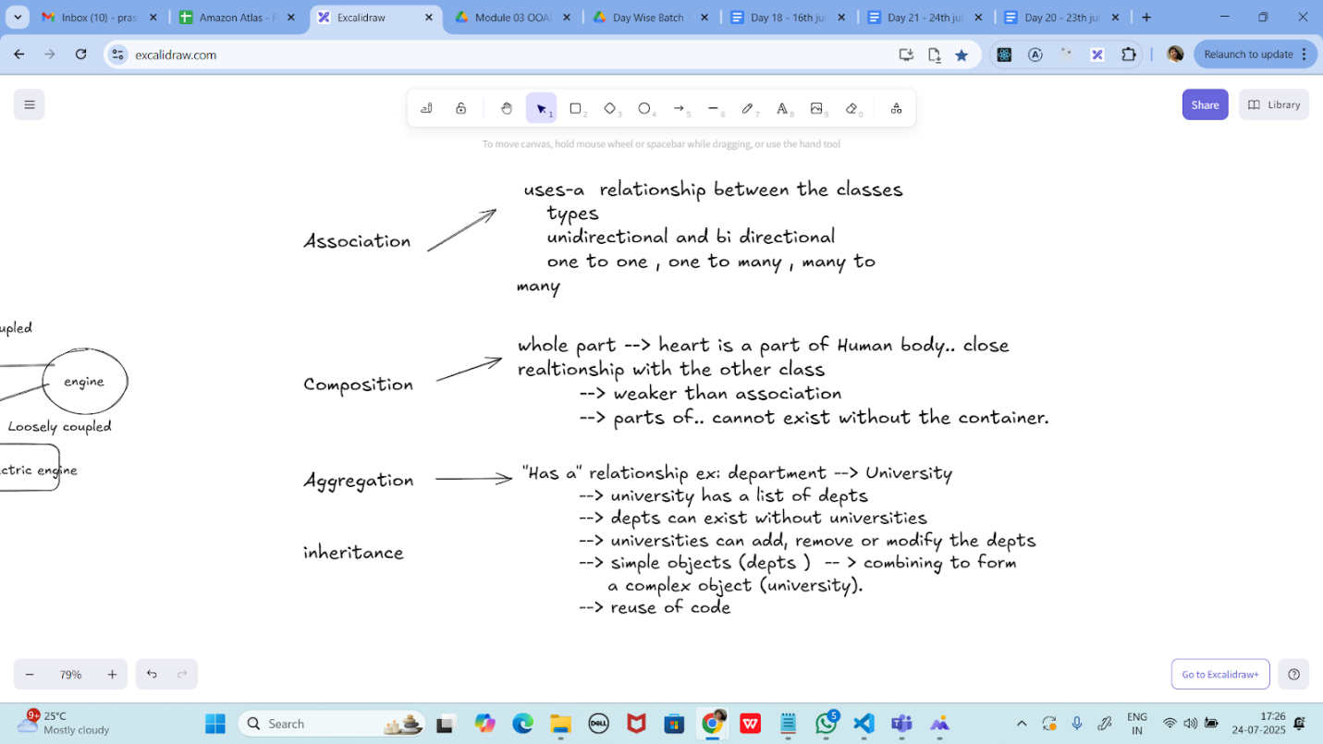

Task 09:

Why should we choose Composition over Inheritance?

Loose coupling

Flexibility

Better encapsulation

UML representation

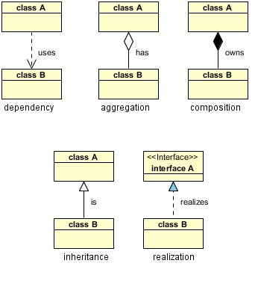

====================================================

Till 15.08…
=================================================

Home Task:

Task 01
Refer the below doc in Docs to study
Doc 07 UML Class Diagrams

Dependency

Task 02:

Aggregation

Task 03:

Composition
Task 04:

Based on the diagrammatic representation can you write a program.

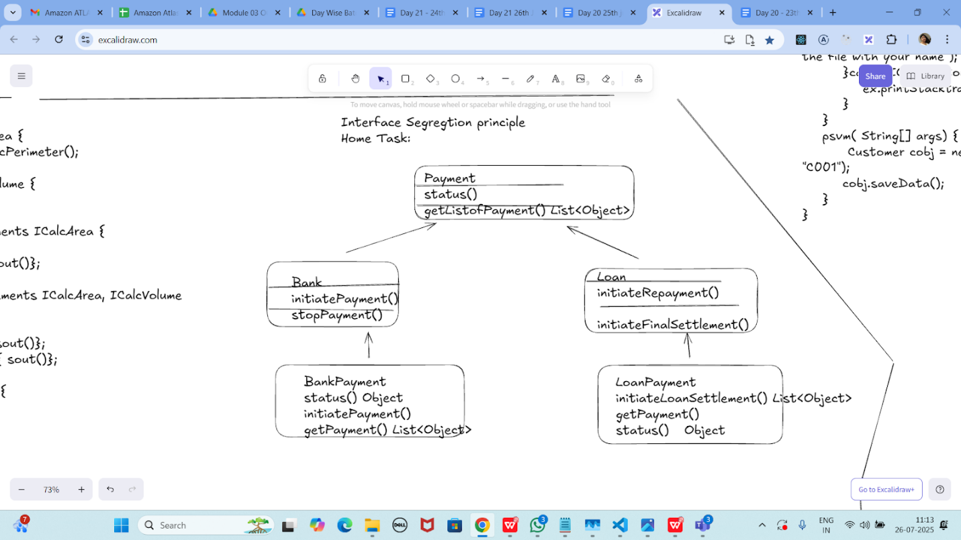

Task 05:

Violation of Liskov

abstract class Bird {
abstract void fly() ;
}
class Eagle extends Bird {
@Override
public void fly() {
sout(" Eagles fly");
}
}
class Ostrich extends Bird {
@Override
public void fly() { // dummy implentation
sout("cant fly high but It lays big egg");
}
}
class Driverclass{
psvm(String[] args){

}
}

Task 06:

Implementation of Liskov

abstract class BirdsthatFly {
abstract void fly() ;
}
abstract class BirdsthatDontFly {
abstract void Speciality() ;
}
class Eagle extends BirdsthatFly {
@Override
public void fly() {
sout(" Eagles fly");
}
}
class Ostrich extends BirdsthatDontFly {
@Override
public void Speciality() {
sout("It lays big egg");
}
}
class Driverclass{
psvm(String[] args){

}
}

Task 07:

Violation of Interface Segregation principle

interface ICalcShapesArea {
calcArea();
calcVolume();
}
class Circle implements ICalcShapesArea {
calcArea() { sout()};
calcVolume() { sout()}; // dummy implentation as it been forced
}
class Sphere implements ICalcShapesArea {
calcArea() { sout()};
calcVolume() { sout()};
}
class Driverclass {
psvm( ,... ) {
}
}

Task 08:

Implementation of Interface Segregation Principle

interface ICalcArea {
calcArea(); calcPerimeter();
}
interface ICalcVolume {
calcVolume();
}
class Circle implements ICalcArea {
@Override
calcArea() { sout()};
}
class Sphere implements ICalcArea, ICalcVolume {
@Override
calcArea() { sout()};
calcVolume() { sout()};
}
class Driverclass {
psvm( ,... ) {
}
}

Task 09:

Dip violation code:

DIP - Dependency inversion Principle - Violation:

public class Clothes {
void seeRating() {

}
void viewSample() {

}
}
public class Cupboard { // high level class
// completly depending on low level class
//called clothes, books, vessels etc..
Clothes cobj;
void addClothes(Clothes cobj) {

}
void CustomizeClothes() {

}
}

customer asks to add books in the code:

public class Books {
void seeRating() {

}
void readSample() {

}
}

Task 10:

Now DIP implementation:

Implementing Dependency Inversion Principle
public interface IProduct {
void SeeReviews();
void getSample();
}
public class Clothes implements IProduct {
@Override
public void SeeReviews() {

}
@Override
public void getSample() {

}
}
public class Books implements IProduct {
@Override
public void SeeReviews() {

}
@Override
public void getSample() {

}
}
==============================================================

Info box:

=============================================================

https://excalidraw.com/#json=_N42kljaUBYMEJbzBEG_Z,gBOJnMKaULoQxKebr7Hzsw

6. Explain the different types of relationships in UML (association, aggregation, composition, inheritance)
- Association : A relationship between two classes that indicates a connection or link between their objects.
- Aggregation : A special type of association that represents a "has-a" or "part-of" relationship, where one class is a part of another class, but they have separate lifetimes.
- Composition : A stronger form of aggregation, where the contained object's lifecycle is dependent on the container object.
- Inheritance : A relationship where one class (subclass) inherits the structure and behavior of another class (superclass), enabling code reuse and specialization.

================================================================================================================================================

